Chapter 1
Introduction
Solution to Solved Problems

1.S1 Make or Buy
Power Notebooks, Inc. plans to manufacture a new line of notebook computers. Management is trying to decide whether to purchase the LCD screens for the computers from an outside supplier or to manufacture the screens in-house. The screens cost $100 each from the outside supplier. To set up the assembly process required to produce the screens in-house would cost $100,000. The company could then produce each screen for $75. The number of notebooks that eventually will be produced (Q) is unknown at this point.
a. Set up a spreadsheet that will display the total cost of both options for any value of Q. Use trial-and-error with the spreadsheet to determine the range of production volumes for which each alternative is best.
If Power Notebooks purchases the screens, the fixed cost is $0 and the unit cost is $100. These data are entered into B2:B3.
If Power Notebooks manufactures the screens, the fixed cost is $100,000 and the unit cost is $75. These data are entered into D2:D3.
The number of LCD screens needed (Q) is unknown. Cell C6 will be used for this quantity.
In general, Total Cost = Fixed Cost + (Unit Cost)(LCD Screens Needed). This formula is entered into B4 and D4.
Trial and error with the spreadsheet shows that purchasing is cheaper if Q < 4000, manufacturing is cheaper if Q > 4000, and the costs are identical when Q = 4000.
The spreadsheet is shown below.
b. Use a graphical procedure to determine the break-even point for Q (i.e., the quantity at which both options yield the same cost).
To determine the ranges of Q for which each source is cheapest, graph the total cost versus Q, as shown below. The total cost lines cross at Q = 4,000. This is the break-even point for Q.
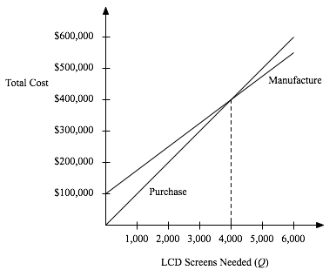
c. Use an algebraic procedure to determine the break-even point for Q.
The total cost if Power Notebooks purchases the LCD screens is TC_{purchase} = ($100)Q.
The total cost if Power Notebooks manufactures the LCD screens is TC_{manufacture} = $100,000 + ($75)Q.
The break-even point for Q occurs when TC_{purchase} = TC_{manufacture}.
($100)Q = $100,000 + ($75)Q when ($25)Q = $100,000, or Q = 4,000.

