**Chapter 1: Legal Foundations**

**CHAPTER OVERVIEW**

This introductory chapter begins with a very broad based view of the legal landscape including a working definition of and purposes of the law, levels and sources of law (e.g., federal statutory), an introduction to stare decisis, and categories of law (e.g., criminal vs. civil). Equally important, this chapter sets the tone for the entire textbook and course by discussing and provides illustrations of how the law operates in a *business* context.

**Teaching Tip: Clean the slate**

Students frequently have certain notions and pre-conceptions about the law and legal terms that were generated primarily (or exclusively) by television, Web sites, blogs, and folklore. Ask students to set aside any notions they have about what law is, how it operates, and the meaning of legal terms, so that they may start the course with a clean slate.

**KEY LEARNING OUTCOMES**

|  |  |
| --- | --- |
| **Outcome** | **Accreditation Categories** |
| Articulate a working definition of and primary purposes of the law, and identify sources, levels and categories of law. | Knowledge |
| Explain the importance of understanding the law in the context of business decision-making and gives examples how the law impacts business. | Application;  Critical Thinking |
| Provide examples of how stare decisis may impact business planning. | Application;  Critical Thinking |

**TEACHING OUTLINE**

**A. Introduction to Law**

*Points to emphasize:*

* Law is a **body of rules** of action or conduct prescribed by controlling authority, and having legal binding force that create duties, obligations and rights as well as a mechanism to resolve disputes arising from those duties and rights.
* ***Jurisprudence:***The philosophy behind the law, including natural law (moral values form the basis for all law), positivists (agreed-upon laws enforced uniformly and strictly) and legal realism (law is a social institution accounting for social and economic realities to promote fairness).
* ***Purposes of Law:***(1) **System of order** that defines crimes and levies punishment for violations; (2) system for **resolving disputes** by providing a basis for deciding the legal interests and rights of the parties; (3) creating **reliability** in business planning and commercial transactions by promoting good faith dealing among merchants and consumers.
* ***Language of the Law:***Primarily a combination of Latin, early and modern English, and French, a basic understanding of which is useful to maximize the value of interaction between business managers and attorneys.

**B. Legal Decisions in a Business Environment: Theory to Practice**

*Points to emphasize:*

* Learning to apply legal awareness in practice involves **recognizing** opportunities for proactive business planning, limiting liability, gaining a competitive edge, and adding value to the business.
* ***Legal Insight and Business Strategy:***Reference to Table 1.1: Expansion Options and Potential Legal Impacts
* ***Role of Counsel:***Managers often work closely with business attorneys, resulting in business opportunities, reduced costs, and limitation of risk and liability.

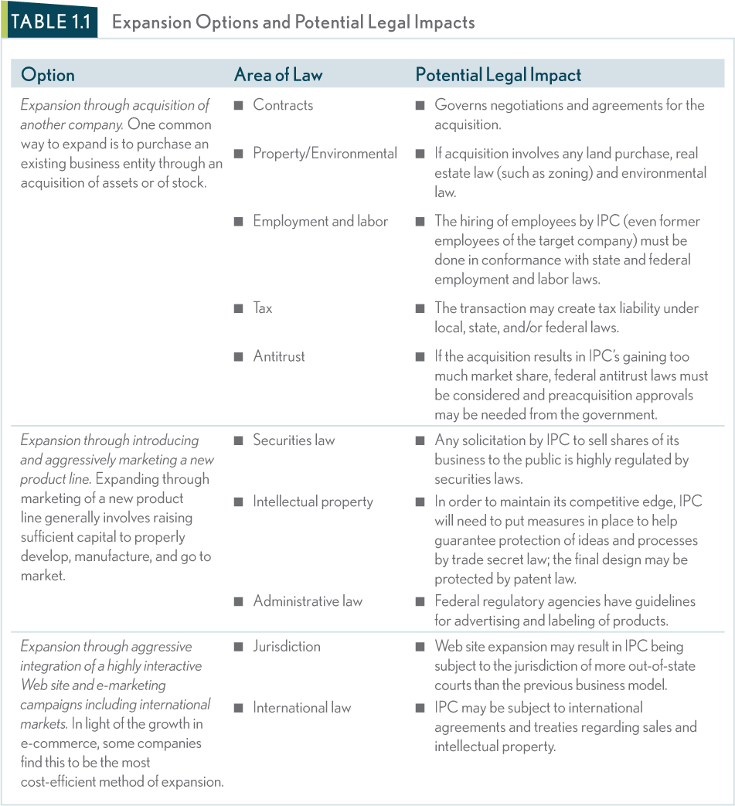

**C. Sources and Levels of American Law**

**Chalk Talk: Sources and Levels of Law**

Covering sources and levels of law in tandem makes sense, but students often have trouble understanding the interplay between the two. I use a diagram on the board and fill in as I go along asking students for examples of each along the way.

Constitutional Statutory Admin Common

Federal First Amendment Patent Act OSHA “gap filler”

(political speech

by corporations)

State Structure of Formation Environmental Contracts

state gov’t of an LLC (regulation of for services.

hazardous materials)

Local Charter: Zoning Sanitary conditions N/A

local gov’t (residential in restaurants

vs. industrial)

*Points to emphasize:*

* Modern law regulating businesses and individuals is generally a **combination of the primary sources of law**: constitutional law, statutory law, common law, and administrative (regulatory) law.
* ***Constitutional Law:***Exists at state and federal levels as the supreme law, providing the foundation for all other law to prescribe the basic **structure** and powers of a particular government body and to protect certain **rights** of individuals and business from government encroachment.

* ***Statutory Law:***Exists at the state, federal and local levels of law, created by a **legislative body** and approved or disapproved by the executive branch.
  + ***Statutory Scheme and Legislative History:***When interpreting statutes courts look to the structure of the law itself (statutory scheme) and to the records kept by the legislature in drafting the statute (legislative history).
  + ***Finding Statutory Law:***The official publication of federal statutory law is in the United States Code and it is arranged by title and divided into chapters and sections that form a citation.
  + ***Gap filling function***: See Case 1.2] **U.S. v. Ulbricht**

**__________________________________________________________________**

**CASE 1.1: U.S. v. Ulbricht**

**Facts:** A federal Grand Jury indicted Ross Ulbricht, also known as Dread Pirate Roberts (Ulbricht), for, among other things, conspiracy to launder money obtained from illegal activities. Prosecutors alleged that Ulbricht was engaged in narcotics trafficking, computer hacking, and money laundering conspiracies by designing, launching, and administering a website called Silk Road as an online marketplace for illicit goods and services. He allowed payment only via bitcoin, an anonymous and untraceable form of digital currency. Thousands of transactions allegedly occurred over the course of nearly three years—sellers posted goods when available; and buyers purchased goods when desired.

Ulbricht filed a motion to dismiss arguing that he could not be guilty of money laundering because the use of bitcoins did not fit into the statute’s requirement that money laundered be a result of a “financial transaction.”

**Issue**: Does the use of virtual currency such as bit coins fit into the money laundering statute requiring that the laundering be the result of a financial transaction?

**Ruling:** Yes. The plain meaning of the statute indicates that “funds” may be defined as bitcoins because they are used to pay for certain things or act as a medium of exchange.

**Answers to Case Questions:**

1. The heart of Ulbricht’s argument is that the statute doesn’t fit his activities or virtual currency. His point about IRS’s treatment of bitcoins as property bolsters his argument that bitcoins cannot be squared with the text of statute (funds).

2. Perhaps. The court plainly believed that Ulbricht created the silk road primarily for illicit activity and therefore he had knowledge that the funds were being “laundered.”

3. *Critical Thinking:* This question is intended to stimulate discussion about the appropriate role of judicial interpretation absent explicit language in the statute. On one hand, if Congress had wanted to include bitcoins as “funds” under the statute, wouldn’t they have done it? On the other hand, shouldn’t courts act as a gap-filler in cases where the legislature could not have accounted for a particular use of funds via bitcoins?

**Teaching Tip: Reading cases**

This is the first case featured in the textbook and an ideal time to discuss the importance of cases in the law. The hybrid format gives students a summary of the facts and of the precise holding related to the point in the text. That point is then reinforced by a short excerpt from the opinion (“Words of the Court”). This is also an ideal time to point out the SUR (Scan, Understand, Read) system featured in **Appendix A of this chapter**: A Business Student’s Guide to Finding and Understanding the Law.

* ***Common Law:***Law made by **appellate courts** and is based on the fundamentals of previous cases that had similar facts.
  + ***Origins:***Deep-seated in British common law that has developed over several centuries beginning around 1066.
* ***Stare Decisis and Precedent:***Appellate courts create precedent and under the doctrine of stare decisis, lower courts apply the precedent to new cases with similar facts.
  + ***Stare Decisis and Business:***Stare decisis allows business to have some **degree of confidence** that the law will remain reasonably consistent. (Reference to Table 1.2: Laws That Impact Business [P.13]
* **Departing from Precedent**: Strict adherence to precedent has a significant drawback- it does not allow for evolvong societal standards of behavior or expectations.

**__________________________________________________________________**

* ***Administrative Law:***The source of law that regulates the exercise of authority by **administrative agencies**.

**D. Secondary Sources of Law**

*Points to emphasize:*

* Secondary sources function to increase the level of uniformity and fairness across all 50 states, however, they have no independent authority, nor are they legally binding.
* ***Uniform Model Laws:***Drafted by legal experts, in hopes that they will be used or adopted by state legislature to provide uniformity in laws between the states (i.e. the U.C.C.).
* ***Restatements of the Law:***Collections of uniform legal principles in a specific area of law that are designed to reduce the complexity of judicial decisions.

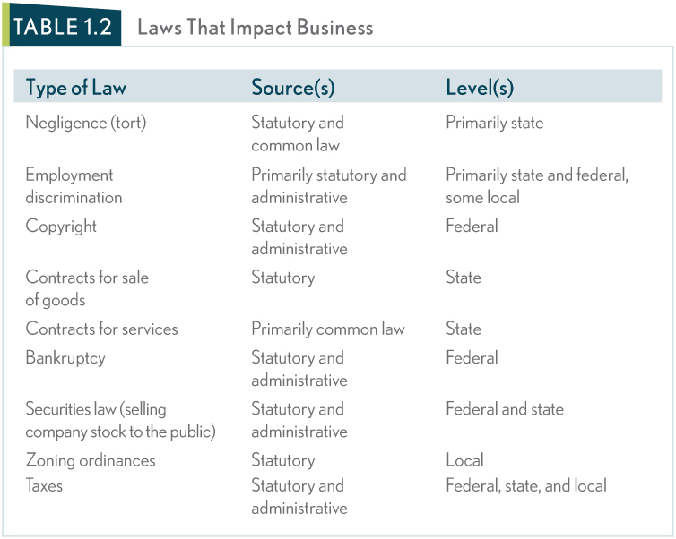

**CASE 1.2 South Dakota v. Wayfair, Inc.**

**Facts:** South Dakota taxes the retail sales of goods and services. Sellers are required to collect and remit the sales tax to the state, but if they do not, then consumers are reaponsible for doing so. Under *National Bellas Hess, Inc v. Department of Revenue of Illinois* and *Quill Corp. v. North Dakota*, South Dakota may not require a business that has no physical presence in the state to collect its sales tax. Because the state was losing sales tax revenue, it passed a law requiring out-of-state retailers to collect and remit the sales tax to the state "as if they had a physical presence in the State." On appeal, the State supreme court ruled in favor of the retailers citing the *Quill* decision.

**Issue:** Are the *National Bellas Hess* and *Quill Corp*. cases controlling?

**Holding:** The United States Supreme Court overruled the State supreme court and found in favor of South Dakota. The Court held that the rule of *Quill* requiring a "physical presence" in the State is unworkable given modetn technology.

**Case Questions:**

1. What was the "physical presence" test?

2. Why did the Court overrule *Quill* and *National Bellas Hess*?

3. *Focus on Critical Thinking*: What other areas of the law might be affected by technology in the future?

**Figure 1.1 : Hierarchy of Primary Sources of Federal and State Law**

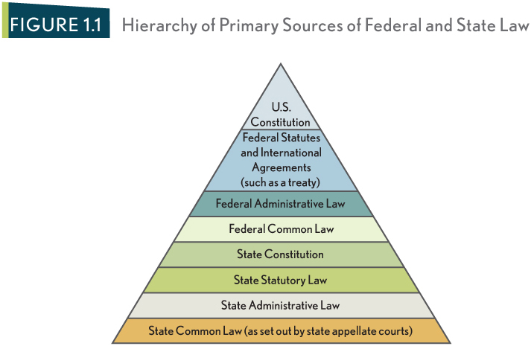

**Concept Summary:** Sources of Law

**Self-Check:** What is/are the source(s) and level(s) of law that govern the following business transactions?

**E. Categories of Law**

*Points to emphasize:*

* Broad categories based on classification related to a particular legal function or a right afforded by law are helpful in understanding the “big picture” of our legal system.
* ***Criminal Law versus Civil Law:***Civil laws are designed to compensate parties for losses as a result of another’s conduct, while criminal laws are a protection of society, and the violation of criminal laws results in penalties to the violator such as fines or imprisonment.
* ***Substantive Law versus Procedural Law:***Substantive laws provide individuals with rights and create certain duties, while procedural laws provide a structure and set out rules for pursuing substantive rights.
* ***Law versus Equity:***Where remedy at law is inadequate, an injured party may also obtain a remedy at equity.
  + Remedies at law generally take the form of **money damages** while **equitable remedies** generally include an injunction or restraining order, and specific performance. **See Case 1.4 for an equitable remedy**

**CASE 1.3: Wilcox Investment v. Brad Wooley Auctioneers, et al**

**Facts:** Wilcox entered into a contract with Wooley Auctioneers, Inc. to market and sell approximately 333 acres of real property owned by Wilcox in Arkansas. It was to be an “absolute” auction, meaning that the property would be sold to the highest bidder regardless of price. As the date of the auction approached, Wilcox expressed reservations about the auction to Auctioneers but decided to go through with the auction. Wilcox did not attend but was represented by two of his children and his attorney. Shollmier was the highest bidder with a bid of $235,000. Wilcox, who claimed the property was appraised in excess of $950,000, refused to complete the sale.

**Issue**: Is specific performance an appropriate remedy or can money serve as an adequate remedy.

**Ruling**: Shollmier is an innocent, non-breaching party. There was no evidence of collusion and Shollmier should be given title to the property as promised in the contract.

**Case Questions:**

1. Money wasn’t adequate because Shollmier contracted for the real estate via his highest bid. Since Wilcox breached his promise before the transaction was contemplated, Shollmier isn’t out of pocket, but is entitled to purchase the property upon the terms and conditions set forth at the auction.

2. Wilcox is alleging that Shollmier conspired with the auctioneers to complete a quick sale at a discounted rate. However, the jury found no evidence of collusion.

3. *Critical Thinking*: This question asks students to think proactively about the law. Wilcox could have stipulated that a minimum auction price be paid as a condition of sale. Instead, he agreed to an “absolute auction” where the seller has virtually no protection on price.

* ***Important Equitable Maxims:*** Intended to be broad statements of rules that are based on notions of fairness and justice in applying the law.
  + ***Equity Aids the Vigilant:*** The law favors those who exercise vigilance in pursuing their claims and disfavors those who rest on their legal rights by failing to act to protect their rights in a reasonable period of time.
  + ***Substance over Form:***When applying the law, courts look to the intent of parties involved and adhere to a standard of good faith instead of applying the black letter law in a way that would violate fundamental principles of fairness and consistency.

**Talking Points: Additional Discussion Questions on** **Substance over Form**

1. Has anyone in this class ever been treated unfairly because the letter of law was applied over fundamental fairness?

2. Has the university/college or any of your professors ever enforced “form over substance” which resulted in you being treated unfairly?

3. In a business context that is absent of any fraud, should courts have the right to decide what is “fair” in a transaction or contract?

* + ***Clean Hands Doctrine:***Courts are not inclined to decide a dispute based on **technicalities** that benefited a party who acted dishonestly.

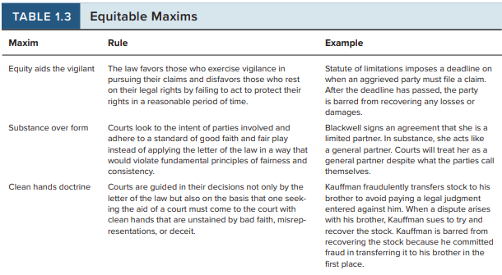

**Strategic Legal Solutions**

Note to Instructor: This is a new feature for this edition and incorporates the use of business strategy into the legal environment. It is important for students to read this overview (and refer back when necessary) which lays out four basic strategies that are discussed throughout the text. The end of each chapter features a “Strategy 101” problem and assignment that is related to one or more subjects covered in that chapter. The examples are intended to connect with business students and to focus on the law as a strategy rather than as a set of rules. For an excellent discussion of the integration between law and strategy, see *American Business Law Journal*, Volume 47 (4) [Winter 2010] where the entire periodical is devoted to the law as a source of strategic advantage. Also, see “Finding the Right Corporate Legal Strategy” a groundbreaking article in MIT’s *Sloane Management Review* by Professors Robert Bird and David Orozco.

Strategy 1: Noncompliance

Example: UPS policy of noncompliance for parking citations. ‘Part of the cost of doing business’

Issues: Cost-benefit analysis; Ethical considerations

Discussion: Is it socially responsible to park in a handicapped spot or fire lane?

Strategy 2: Avoidance

Example: Pfizer’s “tax inversion merger” with Irish Company Allergan to avoid ist U.S. tax burden.

Issues: Cost-benefit; Ethical considerations; U.S. tax policy; Stakeholders

Discussion: Are there any cases in which relocating to a more favorable regulatory environment is justified? Can you think of any examples? (e.g., Uber moving from California to Arizona to test driverless cars).

Strategy 3: Prevention

Example: Disclaimers in consumer contracts; Limiting liability at Fenway Park

Issues: Consumer awareness/fairness; Loopholes

Discussion: In what ways can counsel work with a business to anticipate potential legal pitfalls? (e.g., a labor audit to be sure employees are correctly classified).

Strategy 4: Value Creation/Competitive Advantage

Example: Differentiating one’s business model via durable forms of intellectual property law. Google co-founders were required to assign their first algorithm to Stanford since they developed it while research students there. But subsequent algorithms are trade secrets that don’t expire (like patents do). Disney uses lobbying to extend copyright protection for Mickey Mouse.

Discussion: What other opportunities could business managers use to create value? Could data analytics be used to avoid liability for negligence?

**CHAPTER REVIEW QUESTIONS**

**Answers and Explanations**

**END OF CHAPTER PROBLEMS, QUESTIONS AND CASES**

**Theory to Practice**

1. Galaxy’s business objectives will necessarily involve a lease for the store and therefore contract law will impact business planning. The lease may also be governed by a landlord-tenant law. Jackson’s plan to hire new employees to staff the stores will involve aspects of employment and labor law. [Ties to Table 1.1]

2. Students benefit from understanding that Galaxy will not have in-house counsel, but will rely on a law firm for advice. In this case, Galaxy’s management could work with counsel in understanding various options and being proactive in negotiating a favorable lease and implementing a compliance system to ensure proper hiring and employment practices. [Ties to the “Role of Counsel”]

3. Answer based on Table 1.2

|  |  |  |
| --- | --- | --- |
| **Law** | **Source** | **Level** |
| Contracts for services/land | Primarily common law | State |
| Employment discrimination | Primarily statutory and administrative | Primarily state and federal, some local |
| Tax | Statutory and administrative | Federal, state, local |

Galaxy liability protection could come in several forms. First, the liability can be limited through various provisions in the lease. Second, the liability of Galaxy’s principals may be protected through choosing an appropriate business entity.

4. In this case, Galaxy should learn how the IRS has taxed any similar transactions in past. A primary purpose of the law in a business planning context is *reliability:* similar cases, with similar facts, should be treated (in this case taxed) in a similar way. [Tied to the importance of understanding how stare decisis and precedent can be used in business planning]

5. The equitable maxim of “equity aids the vigilant” may apply to this situation. This maxim favors Jackson/Galaxy in this case because it was Holmes who failed to pursue his legal rights for such a long period of time. [Tied to “Important Equitable Maxims”]

**Manager’s Challenge**

A sample answer to Manager’s Challenge is provided in Connect.

**Case Summary 1.1: Equity and Fairness: Sokoloff v. Harriman Estate Development Corp.**

1. Can Harriman withhold the plans from Sokoloff?

A: No. Doing so would clearly breach a duty owed to Sokoloff.

2. What legal theories or maxims would a court consider in deciding this case?

A: The court would consider the legal theories of equitable relief and/or a remedy at law. The legal maxims that could apply are substance over form and the clean hands doctrine.

3. How should the court rule and why?

A: The court ruled in favor of Sokoloff and ordered specific performance (deliver the plans).

**Case Summary 1.2: Statute of Limitations: Jones v. R.R. Donnelley & Sons Co.**

1. Which statute of limitations governs and why?

A: The federal statute of limitations governs because Jones is bringing a suit that alleges a violation of federal antidiscrimination statues, thus bringing the claim within federal jurisdiction.

2. Will Jones be able to sue Donnelley?

A: Yes, assuming that the cause of action is initiated after 1990, the three years past is within the four-year statute of limitations.

**Case Summary 1.3: Clean Hands Doctrine: Day v. Case Credit Corp.**

1. If the court applies the clean hands doctrine, will Case be able to recover the farm equipment because Day is unable to make payments? Why or why not?

A: No. Courts are not inclined to decide disputes based on technicalities that benefited a party who acted dishonestly and here the transaction was a bad-faith, fraudulent transaction.

2. Are Case’s hands clean? Why or why not?

A: No. Case’s hands are stained by bad faith, misrepresentation and deceit in their awareness of the forgery followed by a failure to act.

**Case Summary 1.4: Cargill v. Montfort**

1. If Monfort files suit and the merger is deemed to violate antitrust laws, what type of remedy will Monfort want to receive and why?

A. Relief in equity because they did not suffer monetary damages.

**Case Summary 1.5: Arizona v. United States**

1. Who prevails and why?

A. The US won at the appellate level based on federal preemption.

2. If a federal law is ineffective, should a state have the right to legislate in that area without federal intervention?

A. Yes, so long as the state law does not frustrate the purpose of the federal law.

**Case Summary 1.6: In re: Sedimentation Pollution Act**

1. How is precedent created, and how is it applied in future cases?

A. By courts of authority starting with the date of the decision.

2. When two separate panels of the same court hear different cases with similar issues, must the second panel follow the decision made by the first?

A. No. Only courts of authority set precedent. Panels are not bound by each other’s decisions.

3. If precedent has been set by a state appellate panel, who has the power to overrule that precedent?

A. Courts of authority (i.e., appellate courts)