Instructors’ Manual and Test Bank

For

Introduction to Audiology
13th Edition

Frederick N. Martin
Professor Emeritus
Communication Sciences and Disorders
The University of Texas at Austin

John Greer Clark
Professor
Communication Sciences and Disorders
University of Cincinnati

Boston Columbus Indianapolis New York San Francisco Upper Saddle River
Amsterdam Cape Town Dubai London Madrid Milan Munich Paris Montreal Toronto
Delhi Mexico City Sao Paulo Sydney Hong Kong Seoul Singapore Taipei Tokyo

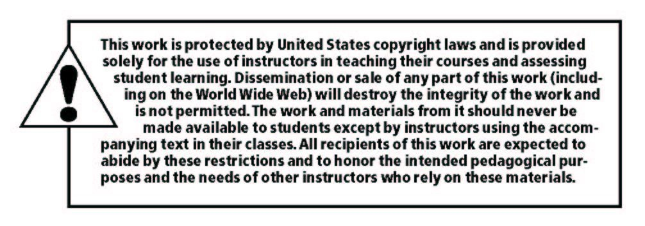

_____________________________________________________________________________

Copyright © 2019, 2015, 2012 by Pearson Education, Inc. or its affiliates. All Rights Reserved. Printed in the United States of America. This publication is protected by copyright, and permission should be obtained from the publisher prior to any prohibited reproduction, storage in a retrieval system, or transmission in any form or by any means, electronic, mechanical, photocopying, recording, or otherwise. For information regarding permissions, request forms and the appropriate contacts within the Pearson Education Global Rights & Permissions Department, please visit www.pearsoned.com/permissions/.

Instructors of classes using Martin & Clark’s Introduction to Audiology, 13th edition may reproduce material from this instructor’s manual for classroom use.

10 9 8 7 6 5 4 3 2 1 ISBN – 10: 0134695550
ISBN – 13: 9780134695556



www.pearson.com

Preface

This book was originally designed as a primary text for a single-term instructional course in audiology. A variety of pedagogical features were incorporated within the first edition of the text to facilitate student mastery of new concepts in the study of hearing diagnostics and treatment. Each edition has seen an increase in coverage of this evolving field of study and the expanding scope of practice of its practitioners. And as coverage has expanded, so have the pedagogical aides provided within the text to support student learning. These include:

- Learning objectives at the beginning of each chapter to direct students’ attention to the material to be introduced.
- Bold facing of all new terms that are fully defined in the glossary at the end of the book.
- A comprehensive glossary that serves as a full dictionary of audiologic terms.
- A large number of illustrative figures with instructional captions throughout the text.
- Summary tables at the end of each chapter.
- An expansion of the instructive “Evolving Case Studies” that are followed from chapter to chapter.
- Twenty demonstrative videos that can be accessed by clicking the video box on the margins of select pages in the e-text.
- A list of frequently-asked questions for each chapter derived from students’ actual queries in class and during office hours.
- Brief examinations following each major section within chapters for self-assessment of learning with immediate feedback on selected answers
- Interactive activities at the conclusion of most chapters that include diagram labeling and matching exercises.

This instructors’ manual and accompanying PowerPoint slides have been created to further facilitate student learning by making the task of teaching audiology courses easier. The provision of examination questions and other materials can serve to free course instructors from some of the more mundane tasks, allowing them to devote their time to other aspects of their teaching.
Instructors are encouraged to use all or any part of the materials in this instructors’ manual to assist in offering audiology courses. Each chapter in this manual opens with a restatement of the chapter’s learning outcomes. These learning outcomes are numbered as they are in the text with numbers corresponding to the major heading within the chapter in which the learning outcome is addressed. Learning outcomes are followed by a listing of vocabulary items to which students will be introduced within the corresponding book chapter. Extrapolation of these vocabulary lists from the text facilitates instructors’ development of study sheets or vocabulary quizzes pertinent to select chapters. For more in-depth assessment of student learning, essay questions, short answer questions and multiple choice questions are provided. A large sampling of case studies is provided for class discussion. Each includes a background history, expected audiometric findings, the diagnosis of the case based on the findings, the probable etiology, discussion of case management and reasons for the decisions drawn. Any portion of any material in this manual may be used in its entirety, edited, substituted, or augmented with other materials.

Table of Contents

Chapter Title Page

- The Profession of Audiology ……………………………………………… 1
- Sound and Its Measurement ………………….……………………………. 6
- The Human Ear, Hearing Loss and Pure-Tone Hearing tests …………… 13
- Speech Audiometry ………………………………………………………. 22
- Masking …………………………………………………………………… 29
- Physiological Tests of the Auditory System ………………………………. 36
- Pediatric Hearing Loss Identification and Assessment …………………… 43
- The Outer Ear ……………………………………………………………. 50
- The Middle Ear …………………………………………………………… 57
- The Inner Ear ……………………………………………………………… 65
- The Auditory Nerve and Central Auditory Pathways ……………………. 73
- Nonorganic Hearing Loss ………………………………………………… 82
- Beyond Hearing: Management of Balance Disorders, Tinnitus,
and Decreased Sound Tolerance ……………………..……………….. 88
- Amplification/Sensory Systems …………………………………………… 95
- Patient Management ……………………….………………………….… 102

Case Studies …………………………………………………………….. 112

Chapter 1

The Profession of Audiology

Compared to other professions in the health arena, audiology is a relative newcomer, emerging from the combined efforts of otology and speech pathology during World War II. Following the war, this new area of study and practice grew rapidly within the civilian sector because of the high prevalence of hearing loss in the general population and the devastating effects on individuals and families when hearing loss remains untreated. To support the needs of those served fully, especially the pediatric population, audiologists often maintain close working relationships with speech-language pathologists and educators of people with hearing impairment. A mutual respect for what each profession brings to auditory (re)habilitation leads to the highest level of remediation for those served.
Today the profession of audiology supports a variety of specialty areas and is transitioning toward a professional doctorate as the entry-level degree. Given projected population demographics, students choosing to enter this profession will find themselves well placed for professional growth and security.

Learning Objectives

The purpose of this opening chapter is to introduce the profession of audiology, from its origins through its course of development to its present position in the hearing-healthcare delivery system. At the completion of this chapter, the reader should be able to

1.1 Describe the evolution of audiology as a profession.
1.1 Discuss the differences between licensure and certification and why an audiologist might choose to become certified.
1.1 Describe the reasons that speech-language pathologists may interact closely with audiologists as they provide services within their chosen professions.
1.2 Discuss the impact of hearing impairment on individuals and society.
1.2 List specialty areas within audiology and the employment settings within which audiologists may find themselves.

Vocabulary Items

Aural rehabilitation | Otology
Prevalence | Speech-language pathology

Chapter 1 Test Items

Essay Question

- Discuss the economic burden hearing loss presents to society.

Short Answer Questions

- Audiology developed from the professions of ______ and ______.

- A founder of audiology, often called the “father of audiology,” is ______.

- Two professional documents that govern the practice of audiology are ______ and
______.

- The entry-level degree for the profession of audiology is the______.

- The credential required for the practice of audiology in the United States is ______.

- The two organizations most closely associated with audiology are ______ and
______.

- List three areas that are impacted by hearing loss in adults besides hearing sensitivity.

- The work of audiologists in areas of noise is sometimes called ______.

Multiple Choice Questions

- Audiology developed from the professions of
  - Education, and psychiatry
  - Social work and speech pathology
  - Otology and speech pathology
  - Speech pathology and education

- A founder of audiology, often called the “father of audiology,” is
  - Raymond Carhart
  - David Goldstein
  - Jack Katz
  - Jerry Northern

- Two professional documents that govern the practice of audiology are
  - Organizational chart and business plan
  - Scope of practice and code of ethics
  - Statement of professional purpose and rules and regulations document

- The entry-level degree for the profession of audiology is the
  - Master’s degree
  - Ed.D.
  - Ph.D.
  - Au.D.

- The credential required for the practice of audiology in the United States is
  - State license
  - ASHA CCC-A
  - Department of Education registration

- The two organizations most closely associated with audiology are
  - Academy of Rehabilitative Audiology and American Academy of Audiology
  - Academy of Doctors of Audiology and the American Speech-Language-Hearing Association
  - International Hearing Society and American Auditory Society
  - American Academy of Audiology and American Speech-Language-Hearing Association

- Audiology had its beginnings during World War II within
  - Community-based speech and hearing centers serving the hearing needs of returning veterans
  - Military-based aural rehabilitation centers
  - France following the Battle of Verdun and quickly migrated to the United States military hospitals where it blossomed over the next 25 years
  - Hospital speech pathology departments

- A speech-language pathologist’s scope of practice
  - Is clearly delineated from that of audiology with no overlap
  - Allows for the speech pathologist to provide therapeutic aspects of aural rehabilitation and basic checks of hearing aid performance
  - Is limited beyond work with speech, language and voice disorders to the provision of therapeutic aspects of aural rehabilitation

- A life time economic burden of hearing loss computed on an average life expectancy of seventy-one years, the economic burden of hearing loss can exceed
  - $ 250,000
  - $ 500,000
  - $ 750,000
  - $1,000,000

- The majority of audiologists find employment within
  - Hospitals
  - Community speech and hearing centers
  - Private practice
  - Physicians’ offices

Chapter 1 Test Item Answer Key

Essay Item

- The student’s answer should include the high costs for treatment of transitory ear infections as well as the rehabilitation and educational costs for those with permanent hearing loss. In addition, the later costs of lost income potential for adults with hearing loss should be included in the answer. The astute student may also recognize that there is a national impact from reduced taxes when a person with hearing loss is either not gainfully employed or is working in a position beneath the earning potential that might have been present if he or she had normal hearing.

Short Answer Items

- otology, speech-language pathology
- Dr. Raymond Carhart
- scope of practice, code of ethics
- Doctor of Audiology (Au.D.)
- state license
- American Academy of Audiology, American Speech-Language-Hearing Association
- general health, psychosocial well-being, generated income
- industrial audiology

Multiple Choice Items

- c
- a
- b
- d
- a
- d
- b
- b
- d
- c

