**Test Bank**

***For***

**Workplace Communications: The Basics**

**Eighth Edition**

**George J. Searles,** *Mohawk Valley Community College*

***Prepared by***

**Kathy Riley**

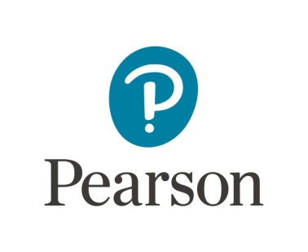

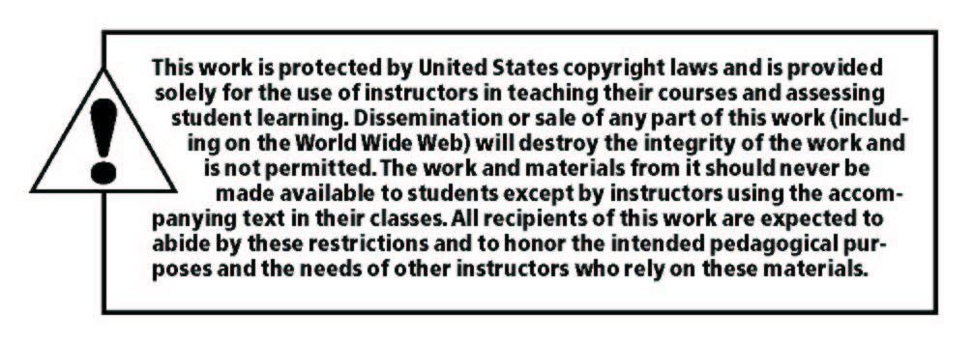

____________________________________________________________________________

Copyright © 2020, 2017, 2014 by Pearson Education, Inc. or its affiliates.  All Rights Reserved.  This publication is protected by copyright, and permission should be obtained from the publisher prior to any prohibited reproduction, storage in a retrieval system, or transmission in any form or by any means, electronic, mechanical, photocopying, recording, or otherwise. For information regarding permissions, request forms and the appropriate contacts within the Pearson Education Global Rights & Permissions Department, please visit [www.pearsoned.com/permissions/](http://www.pearsoned.com/permissions/).

ISBN-10: 0135203104

ISBN-13: 9780135203101

**CONTENTS**

Chapter 1: The Keys to Successful Communication: Purpose, Audience, Tone,

and Ethics 1

Chapter 2: Workplace Correspondence: Memos, E-mail, Text Messages,

and Business Letters 9

Chapter 3: Effective Visuals: Tables, Graphs, Charts, and Illustrations 17

Chapter 4: Short Reports: Page Design, Formats, and Types 25

Chapter 5: Collateral Advertising: Fliers, Brochures, Newsletters, and Websites 32

Chapter 6: Instructions: Guidelines, Alerts, and Procedure Descriptions 39

Chapter 7: Job Application Process: Online Search, Cover E-mail, Résumé, Interview,

and Follow-Up 47

Chapter 8: Oral Presentations: Preparation and Delivery 54

Chapter 9: Proposals: Objectives, Types, and Formats 61

Chapter 10: Long Reports: Format, Collaboration, and Documentation 69

**CHAPTER 1**

**The Keys to Successful Communication: Purpose, Audience, Tone, and Ethics**

**MULTIPLE CHOICE. Choose the one alternative that best completes the statement or answers the question.**

1. Which purpose would be served by a memo asking for supplier prices on a frequently purchased item?

a. persuasion

b. creating a record

c. providing information

d. requesting information

Correct Answer: D

2. Which of the following questions is related to purpose?

a. “Am I writing primarily to create a record, to request or provide information, or to persuade?”

b. “Who will read what I have written?”

c. “What factors might influence the readers’ response to this message?”

d. “Am I writing to one person or more than one?”

Correct Answer: A

3. Which of the following questions relates to ethics?

a. “Am I writing primarily to create a record, to request or provide information, or to persuade?”

b. “Is what I am writing factually correct?”

c. “What factors might influence the readers’ response to this message?”

d. “What do the readers already know about this specific situation?”

Correct Answer: B

4. Which of the following is part of the prewriting stage of the writing process? a. considering the organization of the content

b. creating a first draft, concentrating on content

c. adjusting the tone to suit the audience

d. identifying the purpose and intended audience

Correct Answer: D

5. Which of the following questions can be used to tailor a piece of writing to a particular audience?

a. “What are the readers’ job titles or responsibilities?”

b. “Am I writing primarily to create a record, to request or provide information, or to persuade?”

c. “What factors might influence my skill as a writer?”

d. “Have I credited my information sources?”

Correct Answer: A

6. Which of the following is part of the rewriting stage of the writing process?

a. checking for ethical validity

b. creating a first draft, concentrating on content

c. deciding what needs to be said

d. choosing the most appropriate format

Correct Answer: A

7. Which of the following is an accurate statement about workplace communication?

a. The memo has now been almost totally replaced by texting.

b. Every instance of workplace writing occurs for a specific reason.

c. Every instance of workplace writing is intended for a general audience.

d. Workplace writing should avoid personal pronouns such as *I* and *you*.

Correct Answer: B

8. Which of the following is an example of reader-centered perspective?

a. A public-opinion survey describes 55 percent of the respondents as a “substantial majority.”

b. An employee assigned to prepare a report submits a similar report written by someone at another company and downloaded from the Internet.

c. A writer uses *please*, *thank you*, and other polite terms.

d. A writer provides detailed statistical information in a report for a general audience.

Correct Answer: C

9. What is the main problem with the Fin & Feather Pet Supplies letter in Exercise 1.3 in the text, in which the writer discusses a malfunctioning heating unit?

a. The writer fails to use polite language.

b. The writer fails to tell the reader what action is required.

c. The letter uses incorrect formatting for a business letter.

d. The writer provides inappropriate details about the situation.

Correct Answer: D

10. What is the main problem with the e-mail to Mr. Rhodes in Exercise 1.2 in the text, in which the writer explains why she missed a day of work?

a. The writer fails to apologize for an inappropriate action.

b. The writer should have used a business letter rather than an e-mail.

c. The writer provides inappropriate details about the situation.

d. The subject line is not accurate.

Correct Answer: C

11. Which of the following is an example of a “softening” word or phrase? a. *furthermore*

b. *actually*

c. *if you wish*

d. *OTOH* (meaning *on the other hand*)

Correct Answer: C

12. Which of the following strategies would be appropriate when a problem has been caused by an error or oversight on your part?

a. Don’t mention the error.

b. State specifically what your mistake was.

c. Explain how the situation will be corrected.

d. Create an excuse for the mistake.

Correct Answer: C

13. Which of the following statements is true about whistle-blowing? a. Retaliation against the whistle-blower is easy to prove.

b. The whistle-blower may return to a hostile work environment.

c. Blacklisting rarely affects the whistle-blower’s future job search.

d. A worker’s primary obligation is to follow an employer’s directions, even if they seem unethical.

Correct Answer: B

14. Using terms deliberately chosen for their ambiguity (e.g., “customary service charges”) may create __________.

a. a high-context communication

b. a hostile tone

c. unethical communication

d. upward communication

Correct Answer: C

15. Which of the following raises ethical concerns in writing?

a. documenting sources

b. expressing regret about a mistake

c. full disclosure of information

d. conflict of interest

Correct Answer: D

16. Which of the following is true of idioms?

a. They are recommended when communicating with international audiences.

b. They defy direct translation.

c. They are uniformly understood when communicating across varieties of the same language (e.g., American, British, and Canadian English).

d. They are recommended for highly formal communication.

Correct Answer: B

17. Which of the following follows a strategy for a positive tone?

a. “Your case has been closed and will not be reopened unless you file a new claim.”

b. “Don’t call us after 3:00 p.m. on Fridays.”

c. “Thank you for purchasing our product and for taking the time to contact us about it.”

d. “We feel certain that the unsatisfactory performance of your recent purchase was caused by something you did.”

Correct Answer: C

18. Which of the following indicates a reader quality that places that person higher on the pecking order?

a. an introverted personality

b. more education

c. less access to information

d. greater need

Correct Answer: B

19. Which of the following is true of a casual tone?

a. It should not be adopted with equals.

b. It should not be adopted with subordinates.

c. It should maintain a “business is business” attitude.

d. It may be perceived as combative.

Correct Answer: C

20. Which of the following is true of a casual tone?

a. An excessively conversational tone should be avoided.

b. It is appropriate to adopt with superiors.

c. It is appropriate to include personal information, for example about leisure activities.

d. Personal pronouns should be avoided.

Correct Answer: A

21. Which of the following best describes a writer from the United States communicating with a reader from the Middle East?

a. The writer is from a high-context culture, while the reader is from a low-context culture.

b. The writer is from a low-context culture, while the reader is from a high-context culture.

c. Both the writer and reader are from high-context cultures.

d. Both the writer and reader are from low-context cultures.

Correct Answer: B

22. Which of the following best describes a writer from Asia communicating with a reader from the South America?

a. The writer is from a high-context culture, while the reader is from a low-context culture.

b. The writer is from a low-context culture, while the reader is from a high-context culture.

c. Both the writer and reader are from high-context cultures.

d. Both the writer and reader are from low-context cultures.

Correct Answer: C

23. What purpose would be served by a memo apologizing for a missing part on a recently shipped order and giving the reader a tracking number for a replacement part?

a. persuasion

b. providing information

c. obtaining information

d. requesting information

Correct Answer: B

24. Which of the following is true of business and technical communications in low-context cultures?

a. They emphasize background information.

b. They often contain an interpersonal component.

c. They de-emphasize background information.

d. They are often long-winded.

Correct Answer: C

25. What is the best description of the writer-audience relationship in the letter from the claims adjustor at Southeast Insurance Company in Exercise 1.1 in the text?

a. The writer holds a superior position to the reader.

b. The writer holds a subordinate position to the reader.

c. The writer is a peer (equal) of the reader.

d. The writer doesn’t know who the reader is.

Correct Answer: A

26. Which of the following is true of acronyms and abbreviations frequently used in social media and text messaging (e.g., *OTOH* for *on the other hand*)?

a. Most are appropriate for workplace communication.

b. They will usually be readily understood by readers for whom English is not their native language.

c. They may not be readily understood by older readers.

d. They will usually be readily understood by older readers.

Correct Answer: C

27. Which of the following is true of technical acronyms specific to particular businesses and occupations?

a. Most are inappropriate for workplace communication.

b. They may facilitate dialogue among employees in those fields.

c. They may not be readily understood by older readers.

d. They may facilitate communication with a lay audience.

Correct Answer: B

28. Which of the following is true of business and technical communications in high-context cultures?

a. They emphasize background information.

b. They avoid an interpersonal component.

c. They de-emphasize background information.

d. They are relatively concise, compared to low-context communications.

Correct Answer: A

29. Which of the following is true of an executive reader?

a. The reader has decision-making power.

b. The reader does not possess significant prior knowledge of the field.

c. The reader should be addressed using strategies appropriate for those outside your workplace.

d. The reader doesn’t have the authority to make decisions.

Correct Answer: A

30. Which of the following types of communication is intended for those at your own level in the hierarchy?

a. upward communication

b. lateral communication

c. downward communication

d. outward communication

Correct Answer: B

31. Which of the following types of communication best describes a letter to someone at a company with which you do business?

a. upward communication

b. lateral communication

c. downward communication

d. outward communication

Correct Answer: D

32. Which of the following types of communication best describes an e-mail to an intern you’ve been assigned to train?

a. upward communication

b. lateral communication

c. downward communication

d. outward communication

Correct Answer: C

33. Which of the following types of communication best describes a text message replying to a question from your supervisor?

a. upward communication

b. lateral communication

c. downward communication

d. outward communication

Correct Answer: A

34. Which of the following types of communication best describes a voicemail to a coworker in your department?

a. upward communication

b. lateral communication

c. downward communication

d. outward communication

Correct Answer: B

35. Which of the following tactics might cause a document to fail an ethics test?

a. The writer shares relevant information with coworkers.

b. The writer gives credit for others’ ideas, findings, or written material.

c. The writer uses terms deliberately chosen for their clarity and precision.

d. The writer downplays negative aspects of a situation in order to create the desired impression.

Correct Answer: D

**SHORT ESSAY. Answer the questions below using what you read in the book to help you formulate your answers.**

36. Explain three strategies for making a piece of writing more reader-oriented, and give an example of each.

37. Explain the advantages and disadvantages of sending business correspondence by e-mail rather than by a traditional, mailed letter.

38. Analyze the e-mail from the Chief of Campus Security in Exercise 1.1 in the text in terms of the principles about good tone that it violates.

39. You are reviewing a memo written by an intern whom you supervise and discover that the writer has included a paragraph from a competitor’s website (without any attribution). How would you proceed?

40. You are writing a memo to your coworkers explaining a new procedure for requesting travel reimbursement, and, in addition, you are sending a copy to your supervisor. Who is your primary audience in this case? Explain any strategies you might use to adjust your tone.